**Working of an Eye**

**Eye**

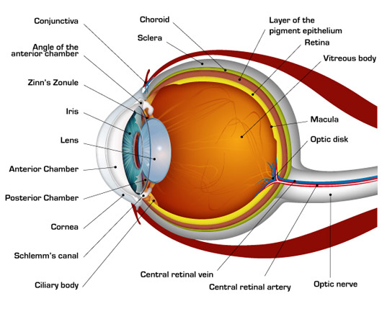The main function of the eyes is to enable people to see. All the parts of the eye work together to allow vision. They take in light from the environment and send visual information to the brain.

**Anatomy of the eye**

There are three main types of tissue in the eye:

1. refracting tissues that focus light
2. light-sensitive tissues
3. support tissues

**Refracting tissues**

Refracting tissues focus incoming light onto light-sensitive tissues to give a clear, sharp image. If tissues are the wrong shape, misaligned, or damaged, vision can be blurry.

The refracting tissues include:

**The pupil**

This is the dark spot in the center of the colored part of the eye. The colored part is called the iris. The pupil expands and shrinks in response to light.

In bright light, the pupil constricts to protect the sensitive retina from damage. In low light, it dilates. This allows the eye to take in as much light as possible.

**Iris**

This is the colored part of the eye. It has muscles that control the size of the pupil and the amount of light that reaches the retina. In this way, it is similar to the aperture on a camera.

**Lens**

After it travels through the pupil, light reaches the lens. This is a transparent, convex structure. The lens can change shape, helping the eye focus light accurately onto the retina. With age, the lens becomes stiffer and less flexible, making focusing more difficult.

**Ciliary muscle**

This is a muscular ring attached to the lens. As it contracts or relaxes, it changes the shape of the lens. This process is called accommodation.

**Cornea**

The cornea is a clear, dome-like layer that covers the pupil, iris, and anterior chamber. This chamber is a fluid-filled area between the cornea and the iris.

The cornea, like the lashes, eyelids, and tear fluid, protects the eyes from injury and foreign objects, such as dust. It also helps the eye focus by directing light into the eye.

The cornea is densely populated with nerve endings and is highly sensitive. It is the eye’s first defense against foreign objects and injury. Because the cornea must remain clear to refract light, it has no blood vessels.

**Vitreous and aqueous fluid**

Two fluids circulate throughout the eyes to provide structure and nutrients. Vitreous fluid is thick and gel-like and is present in the back of the eye. It makes up most of the eye’s mass.

Aqueous fluid is waterer and circulates through the front of the eye.

**Light-sensitive tissues**

**The retina**

The retina is the innermost layer of the eye. It contains millions of light-sensitive photoreceptor cells that detect light and convert it into electrical signals. These signals are sent to the brain for processing.

Photoreceptor cells in the retina contain protein molecules called opsins that are sensitive to light. The two primary photoreceptor cells are called “rods” and “cones.” When these senses light, they send electrical signals to the brain.

Cones are present in the macula, the central part of the retina. The retina contains around 6 million cone cells. The fovea, a small pit at the center of the macula, has a high density of cone cells and no rods.

Cones help people see in typical light conditions and distinguish colors. There are different types, depending on the color that they are sensitive to. These roughly correspond to:

* red
* green
* blue

Red and green cones mostly occur in the center of the fovea, while the blue ones are mostly around the outside.

Rods generally exist around the edges of the retina. They are responsible for black-and-white vision. They can detect the lowest amounts of light and allow people to see at night. Each eye contains around 125 million rods.

**Optic nerve**

The optic nerve is a thick bundle of nerve fibers that transmits signals from the retina to the brain. Thin retinal fibers called ganglion cells carry light information from the retina to the brain.

The ganglion cells leave the eye at a point called the optic disc. Because there are no rods or cones here, it is also called the “blind spot.”

Different kinds of ganglion cells register different types of visual information. For instance, some are sensitive to contrast and movement, others to shape and detail. Together, they carry all the necessary information from our visual field.

**The brain**

The brain gives depth perception by coordinating the signals from both eyes.

The signals generated by the retina end up in the visual cortex, a part of the brain that processes visual information. The visual cortex brings together impulses from both eyes to create images.

**Support tissues**

There are many support tissues in the eye, including fatty tissue. Three of these are the sclera, the conjunctiva, and the uvea.

**Sclera**

People commonly call this the whites of the eyes. It is fibrous and supports the eyeball, helping it keep its shape. It is attached to muscles that can move the eye in almost any direction.

**Conjunctiva**

The conjunctiva is a thin, transparent membrane that covers the sclera and lines the eyelids. It does not cover the cornea. Tear glands, each about the size of an almond, provide fluid that helps lubricate the eye and protect it from microbes.

**Uvea**

The uvea is the middle layer of the eyeball. It supplies blood to the eye. The iris is part of the uvea, along with the ciliary body and the choroid. The ciliary body contains capillaries, which secrete aqueous humor. The ciliary muscles are connected to zonular fibers. Together, they help adjust the shape of the lens for viewing short or long distances.

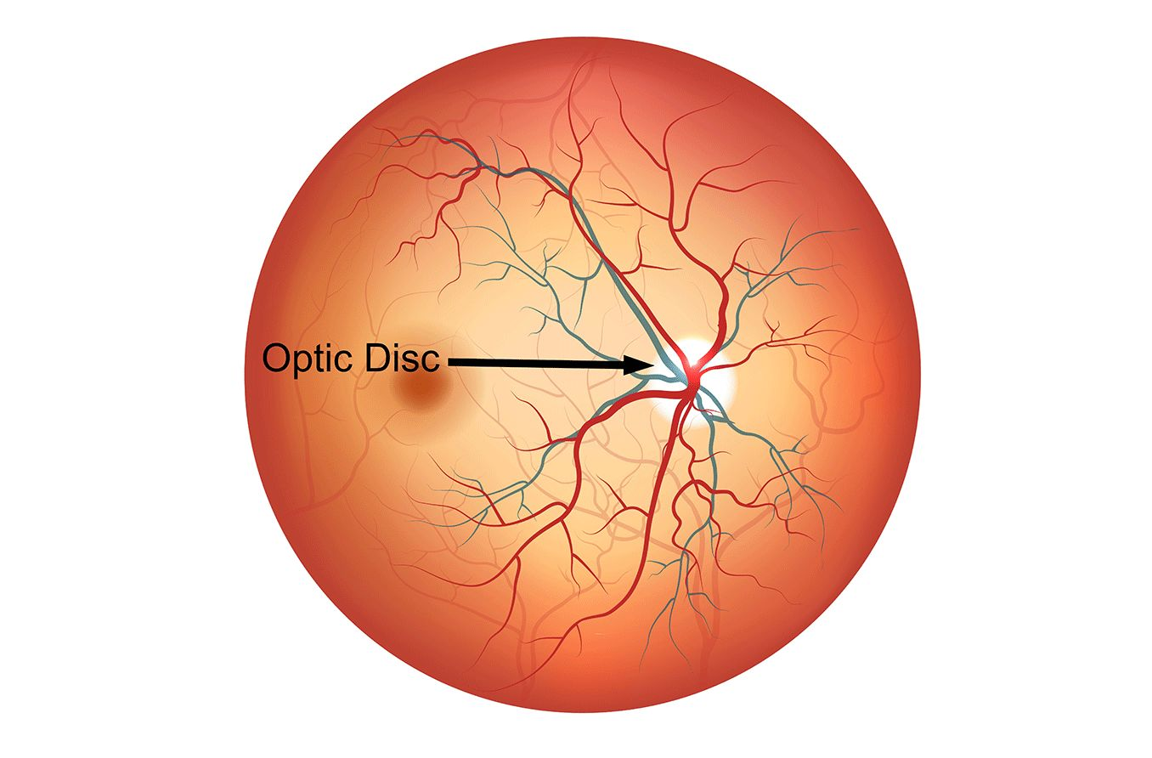**Optic Disks**

The optic disc is an elevation on the medial aspect of the retina where the sensory fibers and retinal vessels pass through the eyeball. The nerve fibers are conveyed via the optic nerve (CN II) and they travel alongside the central retinal artery and vein.

The optic disc is oval-shaped and located exactly 3 mm nasally (medially) to the macula lutea. It has a slight central depression called the physiologic cup. This cup marks a point where the retinal vessels pass.

The optic disc is the only area on the retina without any photoreceptors; hence it is known as the 'blind spot' of the eye.

Because of its visibility upon clinical examination (ophthalmoscopy), it carries great clinical significance. The enlargement of the disc (also known as the edema of the disc or papilledema) may be the first sign of the raised intracranial pressure. In addition, the structural changes of the disc can also indicate the presence of raised intraocular pressure.

About 20-40% of the population also has a small extra artery coming out of the optic disc, called the cilioretinal artery. The cilioretinal artery delivers blood to the center of the macula.

**Optic Cup**

The optic cup is the white, cup-like area in the center of the optic disc. It's smaller than the optic disc. For a healthy patient, the optic cup is one-third of the optic disc.

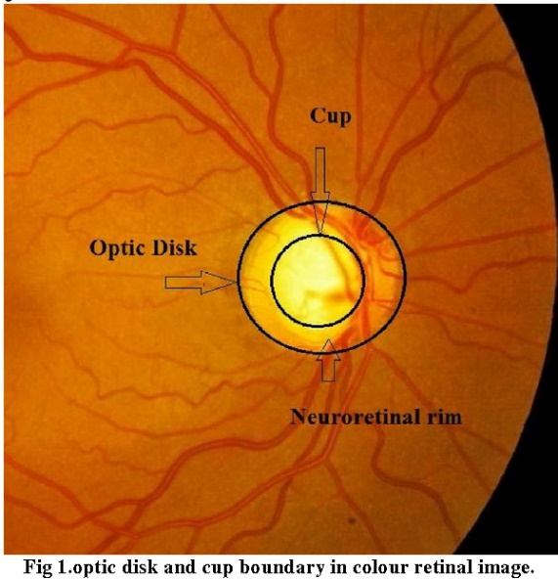

**Disk Ratio**

The cup-to-disc ratio (often notated CDR) is a measurement used in ophthalmology and optometry to assess the progression of glaucoma.

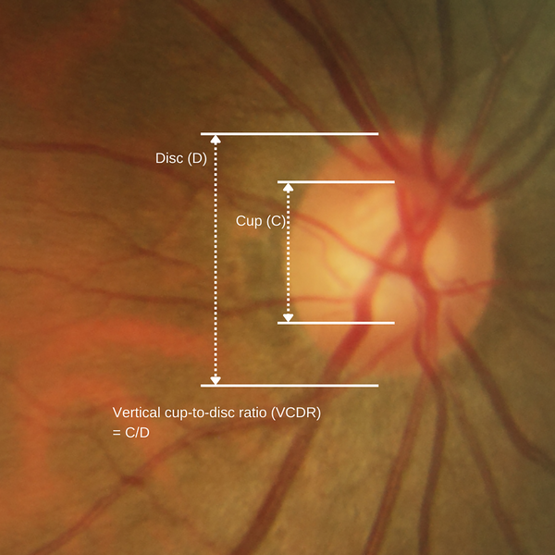The cup-to-disc ratio compares the diameter of the cup portion of the optic disc with the total diameter of the optic disc. The normal cup-to-disc ratio lies between 0.4 - 0.8. A large cup-to-disc ratio may imply glaucoma o

**Eye Disease**

More than 4.8-78 million people in India meet the definition of “legal blindness”.

A few of these diseases are:

1. **Macular degeneration**

Macular degeneration (also called age-related macular degeneration or AMD) is an eye disease that affects your central vision. It damages the macula, which is the center area of your retina that allows you to see fine details. It’s the leading cause of vision loss in people over the age of 60.

Macular degeneration can either be wet or dry. Wet AMD happens when abnormal blood vessels grow under the macula and leak blood and fluid. This damages the macula and leads to loss of central vision. Dry AMD results in the thinning of the macula, which blurs your central vision over time. Dry AMD is more common than the wet form, accounting for 70% to 90% of cases.

Although there is no cure, treatment can slow the progress of the disease or prevent severe vision loss. Recent advances have been made in the treatment of wet AMD using intraocular injections of anti-VEGF medications.

1. **Cataract**

A cataract is a clouding of your eye’s lens. This cloudy lens can develop in one or both eyes. Cataracts are the world’s leading cause of blindness. Cataracts can occur at any age and even be present at birth but are more common in people over the age of 50.

Symptoms of a cataract include:

* Cloudy/blurry vision.
* Glare around lights at night.
* Trouble seeing at night.
* Sensitivity to bright light.
* Need for bright light to read.
* Changes to the way you see color.
* Frequent changes to your eyeglass prescription.

Surgery to remove and replace the cloudy lens with an artificial lens is highly successful with more than 90% of people seeing better after cataract removal.

1. **Diabetes-related retinopathy**

Diabetes-related retinopathy is a disease in which there’s ongoing damage to blood vessels in the retina due to long-term unmanaged high sugar (glucose) levels in your blood. Your retina is the light-sensitive tissue in your eye that is needed for clear vision. Most people with diabetes-related retinopathy show no vision changes until the disease is severe. In others, symptoms come and go.

Symptoms include:

* Blurred or distorted vision.
* New color blindness or seeing colors as faded.
* Poor night vision.
* Small dark spots or streaks in your vision.
* Trouble reading or seeing faraway objects.

Treatments include injections of a specific type of medication and surgery that addresses repairing or shrinking blood vessels in the retina.

1. **Refractive eye conditions**

Refractive eye problems cause you to have issues with focus. Light is improperly bent as it passes through your cornea and lens. These refractive errors are the most common eye problems. Refractive errors include nearsightedness (myopia), farsightedness (hyperopia), and distorted vision at all distances (astigmatism). These eye conditions can be helped with eyeglasses, contacts, or surgery.

1. **Glaucoma**

Glaucoma is a condition that damages your eye's optic nerve, and it gets worse over time. It's often linked to a buildup of pressure inside your eye. Glaucoma tends to run in families. You usually don’t get it until later in life.

The increased pressure in your eye, called intraocular pressure, can damage your optic nerve that sends images to your brain. If the damage worsens, glaucoma can cause permanent vision loss or even total blindness within a few years.

**Causes**

The fluid inside your eye, called aqueous humor, usually flows out of your eye through a mesh-like channel. If this channel gets blocked or the eye is producing too much fluid, the liquid builds up. Sometimes, experts don’t know what causes this blockage, but it can be inherited, meaning it’s passed from parents to children.

Less common causes of glaucoma include a blunt or chemical injury to your eye, severe eye infection, blocked inside your eye, and inflammatory conditions. It’s rare, but eye surgery to correct another condition can sometimes bring it on. It usually affects both eyes, but it may be worse in one than the other.

**Types**

There are two main types:

* **Open-angle glaucoma.** This is the most common type. Your doctor may also call it wide-angle glaucoma. The drain structure in your eye (called the trabecular meshwork) looks fine, but the fluid doesn’t flow out like it should.
* **Angle-closure glaucoma.** This is more common in Asia. It is also called acute or chronic angle-closure or narrow-angle glaucoma. Your eye doesn’t drain like it should because the drain space between your iris and cornea becomes too narrow. This can cause a sudden buildup of pressure in your eye. It’s also linked to farsightedness and cataracts—a clouding of the lens inside your eye.

Less common types of glaucoma include:

* **Secondary glaucoma.** This is when another condition, such as cataracts or diabetes, causes added pressure in your eye. Inflammation inside your eye (your doctor will call this uveitis) can cause you to see halos. Bright lights might bother your eyes.
* **Normal-tension glaucoma**. This is when you have blind spots in your vision or your optic nerve is damaged although your eye pressure is within the average range. Some experts say it’s a form of open-angle glaucoma.
* **Pigmentary glaucoma.** With this form, tiny bits of pigment from your iris (the colored part of your eye) get into the fluid inside your eye and clog the drainage canals.

**Glaucoma Symptoms**

Most people with open-angle glaucoma don’t have symptoms. If symptoms do develop, they are usually late in the disease. That’s why glaucoma is often called the "sneak thief of vision." The main sign is usually loss of side, or peripheral, vision.

Symptoms of angle-closure glaucoma usually come on faster and are more obvious. Damage can occur quickly. Some of the symptoms are:

* Seeing halos around lights
* Vision loss
* Redness in your eye
* Eye that looks hazy (particularly in infants)
* Upset stomach or vomiting
* Eye pain

**Why Glaucoma detection is important?**

It is the second cause of blindness in the Western world and 50% of people suffering from it in the developed world are unaware of it.

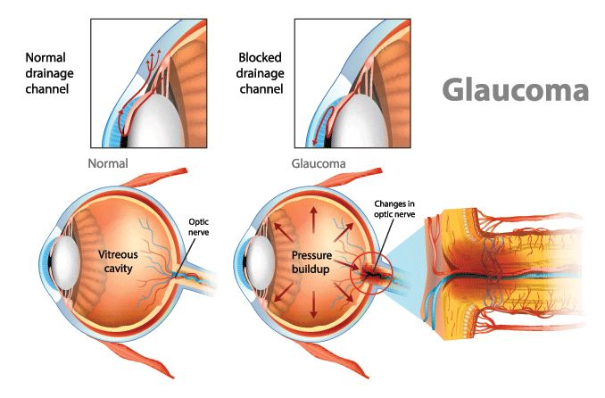

Glaucoma is a progressive eye disease that leads to vision loss and, often, blindness. It develops when internal eye pressure is too high for the optic nerve to withstand. In most cases, there aren’t any known causes of glaucoma. However, it is usually related to problems in the eye’s drainage pathway.

If aqueous humor can’t flow out of the eye properly, it causes intraocular pressure (IOP) to rise. Higher IOP can eventually cause serious damage to the optic nerve - the nerve that carries information from the eyes to the brain.

**Glaucoma Risk Factors**

Anyone can develop glaucoma. However, some people are at higher risk than others. Risk factors for glaucoma include:

* Race: Glaucoma is the leading cause of blindness for people of African descent.
* Age: People age 60 and older are more at risk for developing glaucoma.
* Family history: People with a family history of glaucoma are more likely to develop the disease, especially those with a sibling who has the condition.
* High fluid pressure inside the eyes: People with high fluid pressure inside the eyes are at an increased risk.
* Decreased corneal thickness: People with a thinner cornea are at greater risk of glaucoma.

**Glaucoma detection methods**

The traditional basic diagnosis of glaucoma is made by an ophthalmologist based on the IOP data, a degree of functional impairment resulting from the disease through perimetry, and a manual evaluation of the optic nerve and retinal nerve fiber layer (RNFL) structures from fundus images, which are commonly obtained by indirect ophthalmoscopy with a conventional retina photo camera or slit lamp.

In high-income countries, usually, several analyses with optical coherence tomography (OCT) of the optic nerve and RNFL are added, whose evaluations are represented by graphs, which also allow for comparisons with age-matched normative data.

**Early Detection:**

Most of the doctors measure eye pressure during our routine eye check-ups. There are many ways of measuring eye pressure but the most common method is using a Non-Contact-Tonometer(NCT). The normal pressure lies between 10-20 mmHg. If there is a risk of Glaucoma the doctors are then most likely to use an instrument called a Visual Field analyzer to check a person's peripheral vision.

Since Glaucoma can cause the loss of peripheral vision, This instrument is used to check the severity of the disease and monitor for progression

Doctors also often use an instrument called Pachymetry which checks the Thickness of the cornea. According to the studies done, a thinner cornea might indicate a higher risk of developing glaucoma.

**ISNT rule:**

By analyzing the neuroretinal rim in disc photos of normal subjects, **Jonas et al** found that the rim width typically exhibited a specific pattern of the inferior (I) rim being the widest, followed by the superior (S) rim, then the nasal (N) rim, and then the temporal (T) rim being the thinnest. This specific neuroretinal rim pattern was later coined by **Elliot Werner** as the “ISNT rule.”Because neuroretinal rim loss is a hallmark feature of glaucoma,patients who deviate from the ISNT rule may need to be watched more closely for glaucoma. 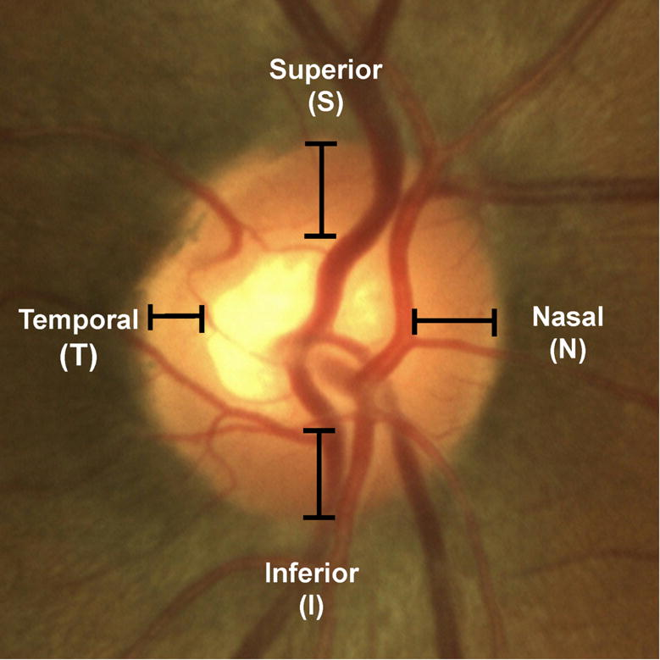

**Retinal fundus images**

The fundus examination is a non-invasive and vital test for detecting systemic diseases of the microcirculation in the human retina, such as glaucoma, which is confirmed by the presence of directly observable features in the optic disc. This includes the whitish central part indicating the absence of neural tissue (called the “optic cup”), glaucomatous optic neuropathy, changes in the RNFL, and peripapillary atrophy (PPA). It is also evaluated via the cup-to-disc ratio (CDR), calculated based on the ratio of the vertical cup diameter (VCD) to the vertical disc diameter (VDD). The cup-to-disc ratio (CDR) is measured as a fractional percentage, and optical cups greater than 0.65 indicate possible abnormalities.

Further observations can be made about changes in the thickening of the neuroretinal rim (which follows a specific pattern of width in healthy people). In the neuroretinal rim, the inferior rim (I) is the widest, followed by the superior rim (S), nasal rim (N), and finally the temporal rim (T). This pattern collectively identified as the inferior, superior, nasal, temporal (ISNT) rule, is widely used in optic nerve-head evaluation. Additionally, the size of the optic disc is important; large discs usually have large cups (resembling and overestimating glaucoma), and in small discs, even a small cup might be glaucomatous (underestimating glaucoma).

